Summary of Eviction Prevention Pilot Programs

According to analysis done by the Community Benchmarks program at the Maxwell School of Citizenship and Public Affairs, an average of 25% of Syracuse residents move at least once a year. In some census tracts that number is more than 35%.
The average rate is higher than Rochester, Albany, and Buffalo, and more than twice the national average of 11.2%. For children under the age of 17, 21% move at least once a year, with that number more than doubling to 43% in some census tracts. When we look at just our renter population, these numbers are higher.

Averages of 11,000 residents are evicted each year in Syracuse. According to Maxwell’s study, that’s approximately 13-16.7% of our renter population. The largest cause of eviction is the tenant’s inability to pay their rent on time. In Syracuse, almost 55% of our renters spend 30% or more of their income on housing costs, including rent and utilities. This rate of housing cost burden is well over 60% in some of our census tracts.

According to Matthew Desmond in his 2016 book Evicted: Poverty and Profit in the American City, people who have frequent forced moves are 15% more likely to lose their jobs, experience a 20% increase in material hardship, and are 25% more likely to have chronic housing problems. For children, experiencing three or more moves reduces their probability of graduating high school by 10-14%.

Housing stability is one of our Mayoral objectives. In 2018, the City of Syracuse Department of Neighborhood and Business Development invested Emergency Solutions Grant (ESG) and Community Development Block Grant (CDBG) funding to pilot two eviction prevention programs. One program was with the Syracuse Housing Authority (SHA) and Volunteer Lawyers Project, working together to reduce the number of residents being brought to eviction court. The other program was with Clinton Plaza, a private subsidized housing complex and a not-for-profit, Catholic Charities, who offered early intervention housing case management services for tenants of Clinton Plaza. Below is a summary of the different methods used by the two properties, lessons learned, benefits and impact.

1) Syracuse Housing Authority (SHA) and Volunteer Lawyers Project | Early Intervention
In 2017 the SHA filed 834 eviction petitions, where 60 resulted in actual families being evicted. While actual evictions were a small percent of those filings, the process itself can be stressful, scary, and disruptive, not to mention costly. In 2018, the number of filings dropped to 203, where only 27 tenants were evicted, resulting in a 75% reduction of eviction filings.

This reduction is the result of the collaboration between the Volunteer Lawyers Project and the Syracuse Housing Authority (SHA). Prior to instituting the Eviction Prevention Program, SHA would file for an eviction once a resident fell behind on rent as a method of getting tenants to pay their rent or make payments for their rent arears. This method was not working.

Moving to an early intervention case management model, two new case managers were hired to identify tenants that may need supportive services when they first began falling behind on their rent, in an attempt to intervene before their rent delinquency put them at risk of being evicted as well as assisting the tenants in getting caught up with their rent to prevent eviction. SHA redesigned their outreach process with property managers, using behavioral economics to get people to open the mail and try different outreach techniques.

Once a tenant falls behind on rent, the process goes as follows:
- The property manager alerts Resident Support Services (RSS) at SHA that the tenant missed their rent payment. The RSS Coordinator meets with property managers and collection staff to identify households who are at risk of eviction for nonpayment of rent, housekeeping deficiencies or other serious lease compliance issues.
- Resident Support Services calls the resident first;
- If they can’t connect by phone, a letter is sent out three different times to attempt to get the resident to reach out.
- If none of the letters work, case managers with Resident Support Services go and knock on the door.
- Once Resident Support Services connects with the tenant, they can work with them to determine why they missed rent and what support services they need. They can make sure that the resident’s rent is calculated correctly or change it if the resident had a change in income. They can connect them with the Volunteer Lawyers Project if the tenant is in need of legal services. And they set up an affordable payment plan to pay back their owed rent.

SHA has found that 190 residents had gotten behind on rent during the program period where 155 families became engaged in services. SHA is still working to build stronger relationships and trust with residents and getting families more accustomed to and comfortable with services available. Many people wait until the last minute to reach out, but it’s still reaching out. SHA wants to be able to work with residents and talk through grievances before getting into court.

Through this program, SHA has saved at least $116,119 in eviction filings and lost rent. They have prevented at least 30 families from evictions in 2018 and have protected hundreds more from the trauma of the threat of it.

Syracuse Housing Authority Eviction Petition Filings
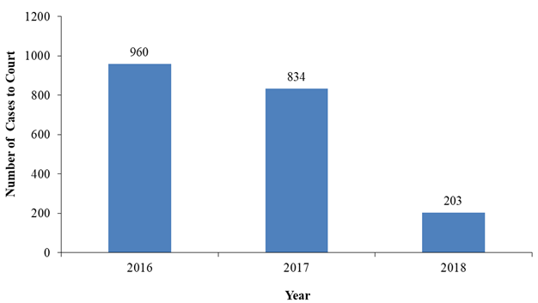
Source: Onondaga Volunteer Lawyers Project Case Data
Pilot Program Highlights:
- In 2018, Resident Support Services prevented 30 families from being evicted;
- Protected 89 families from trauma related to the threat of eviction; and
- SHA saved $116,019 in eviction filings and projected lost rent.

2) Clinton Plaza and Catholic Charities | Early Intervention + Onsite Service Connections
Clinton Plaza and Catholic Charities adopted a similar early intervention case management program starting in May of 2018. Clinton Plaza’s new management team wanted to develop a policy on how to deal with late payments of rent. Prior to new management, there was a culture within the building where it was thought to be acceptable to not pay rent or at least not on time. The new management found itself in a position to get things back under control and didn’t feel comfortable evicting large amounts of tenants. They solicited NBD’s assistance.

Partnering with Catholic Charities for early intervention case management services, the new process works as follows:
- When a tenant fails to pay their rent and the property manager cannot assist, a referral to meet with the Catholic Charities case manager is sent with the late notice.
- The tenant is offered the opportunity to meet with the case manager during set visiting hours, or they can set up an appointment outside of those hours as necessary.
- Catholic Charities works with the tenant to connect them to necessary services such as getting their pet certified as a service animal, setting them up with a cleaning service, making rent adjustments if there was a change in income, and setting up payment plans for missed rent. In the past, tenants were too often evicted due to a disconnect with such services.
- If the case does have to go to an eviction or the tenant is in need of legal services, the tenant is referred to Legal Services of CNY so they can receive free representation. This has often led to the eviction case being able to be settled before it even gets to court.

Catholic Charities has one dedicated case manager for Clinton Plaza so that tenants are always working with the same person and there aren’t any confusing rotations. Since the start of the program (12 months), 88 evictions had to be carried out, sixty-nine (69) families did not have to be evicted, and Clinton Plaza has saved $283,448 the first year preventing evictions.

This program and change in property management policy has also led to a more open and trusting relationship between tenants and the property manager. Tenants now know they can ask for help.

Clinton Plaza | Catholic Charities Program Highlights:
Over a twelve-month period spanning 2018/2019:
- An estimated 69 evictions were prevented;
- Clinton Plaza had an estimated cost savings of $283,448; and
- 83 households received case management services from Catholic Charities.

S:\Federal Grants\ESG\ESG Year 45 (2019-2020)\Eviction Prevention\Eviction Prevention Summary REV 07.10.2019.docx

